HERITAGE | 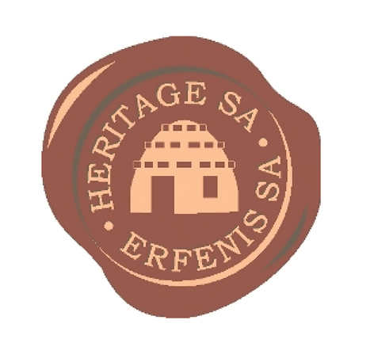 | SOUTH AFRICA

10th Symposium of
Heritage South Africa 2012

From survival to opulence in 100 years
The rise of the 18th century Cape Manor House

Toringkerk Hall, Paarl
Thursday 4, Friday 5 and Saturday 6 October 2012

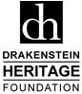 Hosted by the Drakenstein Heritage Foundation, Paarl

…………………………………………………………………………………………….

2012 Symposium theme
This year the Symposium theme revolves around the development of the 18th century Cape Manor House, the economy of the Cape in the 18th century, and the factors that contributed to the wealth of the settlers at the Cape – to the extent that Governor Rijk Tulbagh felt compelled to issue the “Prag and Praal” laws to curb the show of opulence.

……………………………………………………………………………………………..

A decade of Symposiums
This Symposium is hosted annually by heritage societies affiliated to Heritage South Africa (formerly the Simon van der Stel Foundation) at different venues across the country. This is the 10th anniversary of the inaugural Symposium held in Paarl in 2002.

…………………………………………………………………………………………….

Who should attend?
Everyone is welcome. The Symposium will be of special interest to members of heritage societies and those who are interested in heritage and cultural history of all the people of South Africa.

…………………………………………………………………………………………….

PROGRAMME
(Programme subject to change. Find a constantly updated programme at www.heritagesa.org)

Thursday 4 October

11:00: Heritage South Africa Annual General Meeting. All representatives of heritage societies around the country are urged to attend. Interested persons are welcome. Laborie main house, Paarl.

18:00: Function to commemorate forced removals of black and coloured communities by the Apartheid state during the late 50s and 60s – at Nelson’s Creek, Paarl. A powerpoint presentation of the unveiling of Blue Heritage Plaques at De Poort, Skool Street, Die Ou Tuin, Berg Street and Market Street will be shown. Memories of old Paarl will be relived: historic photographs and memorabilia will be on display, and there will be talks by people who experienced the removals first-hand. This event is organised by a committee of former Paarl West home owners under the auspices of the Drakenstein Heritage Foundation.
For an invitation, contact: Cathy Raymond at heritage@iafrica.com. Heritage organisation members free.

Friday 5 October

08:30 Registration

09:00 Welcome by Mickey Kent, Chairman of Heritage South Africa
Announcements

09:30 Paarl Valley – Earth heritage in action: the early geological history that led to the great fertility of the Valley – Prof Izak Rust, formerly Dean of the Science Faculty and Geology professor, University of Port Elizabeth

10:15 The earliest inhabitants of the south-western Cape and the adjacent hinterland – Dr Judy Maguire, palaeontology and heritage specialist and Chairperson of the Prince Albert Cultural Foundation

11:00 TEA

11:20 The Khoi and the 1st frontier war – Prof Nigel Penn, Department of Historical Studies, University of Cape Town

12:10 The 18th century economic development at the Cape – Johan Fourie, Stellenbosch University

13:00 LUNCH

13:50 Heritage South Africa website – Carol Podd, Heritage South Africa

14:05 The contribution of the slaves to the development at the Cape – Prof Rob Shell, Historical Demography, University of the Western Cape, and Population and Ecology, CPUT

15:00 Preview of afternoon walkabout – Len Raymond, Chairman of Drakenstein Heritage Foundation

15:20 TEA

16:00 Walkabout in Mill Street, Paarl, to view 18th century manor houses with Len Raymond

19:00 PRE-DINNER DRINKS at Laborie Manor House

19:45 GALA DINNER AND AWARDS CEREMONY at Laborie Restaurant

Saturday 6 October

09:00 Meet at the Toringkerk Hall
Heritage business and introduction to the day's farm visits – Len Raymond

09:30 TEA
Coaches will provide transport for the rest of the day.

10:30 – 17:00 Visits to 18th century farms in the Paarl Valley:

10:30 Farm Amstelhof manor house

11:30 More farm visits

13:00 LUNCH at Babel Restaurant

14:00 Farm Babylonstoren manor house and garden

15:30 Farm Donkerhoek manor house

16:30 TEA

16:50 Conclusion and acknowledgements – Len Raymond, Chairman of Drakenstein Heritage Foundation

……………………………………………………………………………………………………..

COSTS, BOOKING, ACCOMMODATION

Go to website www.heritagesa.org

Enquiries:
Cathy Raymond at heritage@iafrica.com
………………………………………………………………………

